**IOT BASED CONTROL SYSTEM FOR AIR POLLUTION DETECTION IN VEHICLES**

**Abstract:**

Air pollution is a critical problem that is currently plaguing Asia in the perilous fight against environmental pollution. It refers to the harmful substances and pollutants in the air that play an essential role in the depletion of the ozone layer while being a grave hazard to the ecological system. A principal cause of air pollution is the increase in vehicular traffic, especially in Asia, that has been noted in recent years. The combustion reaction that occurs when cars burn gasoline leads to the emission of Carbon Monoxide (one of the principal constituents of air pollution). According to many recent studies, Carbon Monoxide is fatal enough to cause health issues which may lead to death in some extreme cases. Thus, it comes as no surprise that regulating car pollution is a paramount step in finding a solution to this global issue. Therefore, we are developing a system using a carbon monoxide sensor and NODEMCU microcontroller, which detects the gas emission from the car exhaust. Internet will play an important role in the communication of physical things. Physical objects can be empowered through the embedded electronics into it, to make them smart and at the same time IoT gives the connection among these objects to give high quality of life to the people. Hardware, software components works cooperatively to build the IoT. This technology is used in the development of air pollution detection system.

**SOFTWARE AND HARDWARE TOOLS:**

**Software Tools:**

1. Arduino IDE

**Hardware Tools:**

1. NODEMCU
2. MQ2 SENSOR
3. BUZZER
4. POWER SUPPLY

**CHAPTER – I**

**INTRODUCTION**

Now days, IoT (Internet of Things) is a new revolution of the Internet and it provides a platform for communication between objects where objects can organize and manage themselves. Internet of Things (IoT) is the expansion of internet services because it allows daily life things to connect with user and operate remotely from anywhere. We can describe IoT in simple words, when the objects or things connected with each other using standard protocols and standard infrastructure so that they can communicate between each other and all these objects/things can be monitored and controlled by anywhere and anytime using internet. The IoT was began in the year 1998 and the term Internet of Things was first called by Kevin Ashton in 1999 [4]. The Internet of Things is a new area where it provides a privilege to communicate around the world. The objective of IoT is Anything, Anyone, Anytime, Anyplace, Any service and any network. Fig.1 describes the coupling of two things suppose its C’s and A’s which may be reveals, people and things can be connected Anytime, Anyplace, with Anything and Anyone, ideally by using in Any path/network and Any service. This implies addressing elements such as Convergence, Content, Collections (Repositories), Computing, Communication, and Connectivity in the context where there is seamless inter connection between people and things and/or between things and things so the A and C elements are present and tightly coupled

**EMBEDDED SYSTEMS**

An embedded system can be defined as a computing device that does a specific focused job. Appliances such as the air-conditioner, VCD player, DVD player, printer, fax machine, mobile phone etc. are examples of embedded systems. Each of these appliances will have a processor and special hardware to meet the specific requirement of the application along with the embedded software that is executed by the processor for meeting that specific requirement. The embedded software is also called “firm ware”. The desktop/laptop computer is a general purpose computer. You can use it for a variety of applications such as playing games, *word* processing, accounting, software development and so on. In contrast, the software in the embedded systems is always fixed listed below:

· Embedded systems do a very specific task, they cannot be programmed to do different things. . Embedded systems have very limited resources, particularly the memory. Generally, they do not have secondary storage devices such as the CDROM or the floppy disk. Embedded systems have to work against some deadlines. A specific job has to be completed within a specific time. In some embedded systems, called real-time systems, the deadlines are stringent. Missing a deadline may cause a catastrophe-loss of life or damage to property. Embedded systems are constrained for power. As many embedded systems operate through a battery, the power consumption has to be very low.

· Some embedded systems have to operate in extreme environmental conditions such as very high temperatures and humidity.

**Application Areas**

Nearly 99 per cent of the processors manufactured end up in embedded systems. The embedded system market is one of the highest growth areas as these systems are used in very market segment- consumer electronics, office automation, industrial automation, biomedical engineering, wireless communication, data communication, telecommunications, transportation, military and so on.

**Consumer appliances**: At home we use a number of embedded systems which include digital camera, digital diary, DVD player, electronic toys, microwave oven, remote controls for TV and air-conditioner, VCO player, video game consoles, video recorders etc. Today’s high-tech car has about 20 embedded systems for transmission control, engine spark control, air-conditioning, navigation etc. Even wristwatches are now becoming embedded systems. The palmtops are powerful embedded systems using which we can carry out many general-purpose tasks such as playing games and word processing.

**Office automation:** The office automation products using em embedded systems are copying machine, fax machine, key telephone, modem, printer, scanner etc.

**Industrial automation**: Today a lot of industries use embedded systems for process control. These include pharmaceutical, cement, sugar, oil exploration, nuclear energy, electricity generation and transmission. The embedded systems for industrial use are designed to carry out specific tasks such as monitoring the temperature, pressure, humidity, voltage, current etc., and then take appropriate action based on the monitored levels to control other devices or to send information to a centralized monitoring station. In hazardous industrial environment, where human presence has to be avoided, robots are used, which are programmed to do specific jobs. The robots are now becoming very powerful and carry out many interesting and complicated tasks such as hardware assembly.

**Medical electronics**: Almost every medical equipment in the hospital is an embedded system. These equipments include diagnostic aids such as ECG, EEG, blood pressure measuring devices, X-ray scanners; equipment used in blood analysis, radiation, colonoscopy, endoscopy etc. Developments in medical electronics have paved way for more accurate diagnosis of diseases.

**Computer networking**: Computer networking products such as bridges, routers, Integrated Services Digital Networks (ISDN), Asynchronous Transfer Mode (ATM), X.25 and frame relay switches are embedded systems which implement the necessary data communication protocols. For example, a router interconnects two networks. The two networks may be running different protocol stacks. The router’s function is to obtain the data packets from incoming pores, analyze the packets and send them towards the destination after doing necessary protocol conversion. Most networking equipments, other than the end systems (desktop computers) we use to access the networks, are embedded systems

.

**Telecommunications**: In the field of telecommunications, the embedded systems can be categorized as subscriber terminals and network equipment. The subscriber terminals such as key telephones, ISDN phones, terminal adapters, web cameras are embedded systems. The network equipment includes multiplexers, multiple access systems, Packet Assemblers Dissemblers (PADs), sate11ite modems etc. IP phone, IP gateway, IP gatekeeper etc. are the latest embedded systems that provide very low-cost voice communication over the Internet.

**Wireless technologies**: Advances in mobile communications are paving way for many interesting applications using embedded systems. The mobile phone is one of the marvels of the last decade of the 20’h century. It is a very powerful embedded system that provides voice communication while we are on the move. The Personal Digital Assistants and the palmtops can now be used to access multimedia services over the Internet. Mobile communication infrastructure such as base station controllers, mobile switching centers are also powerful embedded systems.

**Insemination:** Testing and measurement are the fundamental requirements in all scientific and engineering activities. The measuring equipment we use in laboratories to measure parameters such as weight, temperature, pressure, humidity, voltage, current etc. are all embedded systems. Test equipment such as oscilloscope, spectrum analyzer, logic analyzer, protocol analyzer, radio communication test set etc. are embedded systems built around powerful processors. Thank to miniaturization, the test and measuring equipment are now becoming portable facilitating easy testing and measurement in the field by field-personnel.

**Security:** Security of persons and information has always been a major issue. We need to protect our homes and offices; and also the information we transmit and store. Developing embedded systems for security applications is one of the most lucrative businesses nowadays. Security devices at homes, offices, airports etc. for authentication and verification are embedded systems. Encryption devices are nearly 99 per cent of the processors that are manufactured end up in~ embedded systems. Embedded systems find applications in every industrial segment- consumer electronics, transportation, avionics, biomedical engineering, manufacturing, process control and industrial automation, data communication, telecommunication, defense, security etc. Used to encrypt the data/voice being transmitted on communication links such as telephone lines. Biometric systems using fingerprint and face recognition are now being extensively used for user authentication in banking applications as well as for access control in high security buildings.

**Finance**: Financial dealing through cash and cheques are now slowly paving way for transactions using smart cards and ATM (Automatic Teller Machine, also expanded as Any Time Money) machines. Smart card, of the size of a credit card, has a small micro-controller and memory; and it interacts with the smart card reader! ATM machine and acts as an electronic wallet. Smart card technology has the capability of ushering in a cashless society. Well, the list goes on. It is no exaggeration to say that eyes wherever you go, you can see, or at least feel, the work of an embedded system!

**Overview of Embedded System Architecture**

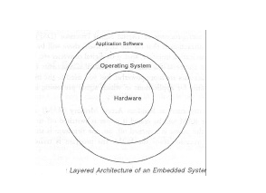Every embedded system consists of custom-built hardware built around a Central Processing Unit (CPU). This hardware also contains memory chips onto which the software is loaded. The software residing on the memory chip is also called the ‘firmware’. The embedded system architecture can be represented as a layered architecture as shown in Fig.

The operating system runs above the hardware, and the application software runs above the operating system. The same architecture is applicable to any computer including a desktop computer. However, there are significant differences. It is not compulsory to have an operating system in every embedded system. For small appliances such as remote control units, air conditioners, toys etc., there is no need *for* an operating system and you can write only the software specific to that application. For applications involving complex processing, it is advisable to have an operating system. In such a case, you need to integrate the application software with the operating system and then transfer the entire software on to the memory chip. Once the software is transferred to the memory chip, the software will continue to run *for* a long time you don’t need to reload new software.

Now, let us see the details of the various building blocks of the hardware of an embedded system. As shown in Fig. the building blocks are;

· Central Processing Unit (CPU)

· Memory (Read-only Memory and Random Access Memory)

· Input Devices

· Output devices

· Communication interfaces

· Application-specific circuitry

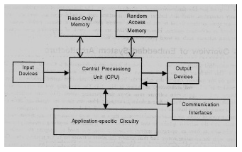

**Central Processing Unit (CPU):**

The Central Processing Unit (processor, in short) can be any of the following: microcontroller, microprocessor or Digital Signal Processor (DSP). A micro-controller is a low-cost processor. Its main attraction is that on the chip itself, there will be many other components such as memory, serial communication interface, analog-to digital converter etc. So, for small applications, a micro-controller is the best choice as the number of external components required will be very less. On the other hand, microprocessors are more powerful, but you need to use many external components with them. D5P is used mainly for applications in which signal processing is involved such as audio and video processing.

**Memory:**

The memory is categorized as Random Access 11emory (RAM) and Read Only Memory (ROM). The contents of the RAM will be erased if power is switched off to the chip, whereas ROM retains the contents even if the power is switched off. So, the firmware is stored in the ROM. When power is switched on, the processor reads the ROM; the program is program is executed.

**Input devices**:

Unlike the desktops, the input devices to an embedded system have very limited capability. There will be no keyboard or a mouse, and hence interacting with the embedded system is no easy task. Many embedded systems will have a small keypad-you press one key to give a specific command. A keypad may be used to input only the digits. Many embedded systems used in process control do not have any input device *for* user interaction; they take inputs *from* sensors or transducers 1’fnd produce electrical signals that are in turn fed to other systems.

**Output devices**:

The output devices of the embedded systems also have very limited capability. Some embedded systems will have a *few* Light Emitting Diodes (LEDs) *to* indicate the health status of the system modules, or *for* visual indication of alarms. A small Liquid Crystal Display (LCD) may also be used to display *some* important parameters.

**Communication interfaces**:

The embedded systems may need to, interact with other embedded systems at they may have to transmit data to a desktop. To facilitate this, the embedded systems are provided with one or a *few* communication interfaces such as RS232, RS422, RS485, Universal Serial Bus (USB), IEEE 1394, Ethernet etc.

**Application-specific circuitry**:

Sensors, transducers, special processing and control circuitry may be required fat an embedded system, depending on its application. This circuitry interacts with the processor to carry out the necessary work. The entire hardware has to be given power supply either through the 230 volts main supply or through a battery. The hardware has to design in such a way that the power consumption is minimized.

**CHAPTER – II**

**LITERATURE SURVEY**

Qingping Chi et al. [1], proposed a new method to design a reconfigurable smart sensor interface for industrial WSN in IoT environment, which is CPLD i.e. complex programmable logic device is adopted as the core controller which provides reading data in parallel and in real time with high speed on multiple different sensor data. Complex programmable logic device solved all previous problems like the current connect number, sampling rate, and signal types of sensors are generally restricted by the device means each sensor connected to the device is required to write complicated and cumbersome data collection program code. In this system the standard of IEEE1451.2 intelligent sensor interface specification are used so that system can collect sensor data intelligently. Fig. 3 shows the System’s block function design.

This system is based on IEEE1451 protocol and by combining with CPLD and the application of wireless communication; it is very suitable for real-time and effective requirements of the high-speed data acquisition system in IoT environment. The system achieved good effects in practical application in taking real time monitoring of water environment in IoT environment as an example and also more flexible and extensible.

Shifeng Fang et al. [2], presents an integrated approach to water resource management based on geoinformatics including technologies such as Remote Sensing (RS), Geographical Information Systems (GIS), Global Positioning Systems (GPS), Enterprise Information Systems (EIS), and cloud services. This paper also introduces a prototype IIS called WRMEIS i.e. Water Resource Management Enterprise Information System that integrates functions such as data acquisition, data management and sharing, modeling, and knowledge management. This system provides best management for water security and flood for human society which is future for human life. This system is combination of Snowmelt Flood Forecasting Enterprise Information System i.e. SFFEIS, which is based on the Water Resource Management Enterprise Information System. This system contains operational database, Extraction-TransformationLoading (ETL), information warehouse; in which it contains information management that allows any participant play the role as a sensor as well as a contributor to the information warehouse, temporal and spatial analysis, simulation/prediction models to predict the atmospheric condition, knowledge management is useful for the taking decision; which is provided by both users and public play the role of providing data and knowledge, and other functions. This system is a prototype water resource management IIS which integrates geoinformatics, EIS, and cloud service. This system provides the crucial importance of a systematic approach toward IISs for effective resource and environment management.

Cheong, P. et al. [3], paper presents a ZigBee-based wireless sensor network node for the ultraviolet i.e. UV detection of flame. This system is based on the sensor node; which is composed of a ZnSSe UV photo detector and also contains current-sensitive front end including a high-gain current-to-voltage amplifier with 120 dB and a logarithm converter, a transceiver operated at a 2.4-GHz industrial, scientific, and medical band. For converting the ultraviolet emission of flame into picoamperes the passive photo detector is designed or set in a such a way that it will having a cutoff at 360 nm and system can detect the flame at the speed of 70 ms. System also contains mixed signal processing for the speed of flame detection is as fast as 70 ms and ZigBee transmission provides send data from the sensor to the central processor system or to the application layer. The systems sensor node consumes only an average of 2.3 mW from a 3.3-V supply. This system is tested under the condition such that the luminous flame was imaged onto the sensor node with different angles ranging from -30° to 30° and distances of 0.1, 0.2, and 0.3 m enabling effective fire safety applications.

GauravTiwari and RiyazKazi [4], present Autonomic Smart Sensor Interface for Industrial in IOT Environment. Sensors are generally restricted by the device because of the current connect number, sampling rate, and signal types and if required to connect devices required to write complicated and cumbersome data collection programming code.to solve this problem this paper provides the new method i.e. design a functional smart sensor interface for industrial WSN in IoT environment, in this field programmable gate array device (FPGA) is adopted as a core-controller. Fig. 4a and 4b shows the proposed system i.e. Autonomic Smart Sensor Interface for Industrial in IOT Environment.

Field programmable gate array device read data in parallel and in real time with high speed on multiple different sensor data and the standard of IEEE1451.4 intelligent sensor interface specification is adopted for this design.

R. KarpagaPriya, T. KarpooraEswari, and K. Akilakumari [5], presents an Industrial WSN in IOT Environment Interface with Smart Sensor Using ARM. This system is to develop a sensor interface device is essential for sensor data collection of industrial Wireless Sensor Networks i.e. WSN in Internet of Things (IoT) environment. In the proposed system ARM is adopted as the core controller at the time of interfacing for industrial WSN in IoT atmosphere so that it will scan information in parallel and in real time with high speed on multiple completely different device information and for this Intelligent device interface specification is adopted. Different Sensors are used to provide the values of Temperature, Vibration, Gas present in the industrial environment, so that critical situation can be avoided and preventive measures are successfully implemented. The result of the system gives values of Temperature is 67.4c. If Vibration and Gas sensor is either Low or Medium, it means Low indicates that there is no gas and vibration, and then Medium indicates there is a Gas and Vibration present.

Bharani M., Elango S., Ramesh S.M., and Preetilatha R. [6], presents an embedded system based monitoring system for industries by interfacing sensors with ATmega Microcontroller. In this system various sensors are being used for measuring the temperature, pressure, gas etc. In the proposed system, sensors are interfaced with the microcontroller ATmega328p which provides a highperformance Atmel 8-bit AVR RISC-based microcontroller combines 32KB flash memory with readwhile-write capabilities, 1024B EEPROM, 23 general purpose I/O lines, 32 general purpose working registers, three flexible timer/counters with compare modes, internal and external interrupts, serial programmable, a byteoriented 2-wire serial interface, serial port, a 6-channel 10- bit A/D, programmable watchdog timer with internal oscillator, and five software selectable power saving modes. Using Zigbee the measured values are sent from monitoring station to the controlling station and then sent via WAN to the Internet if needed. Received values are compared with the threshold value if any mismatch is found then the workers will be informed to take corrective measures.

S.Pandikumar and R.S. Vetrivel [7], presents an IoT and GSM based design of smart home controlling system. This paper provides architecture, which enables the users to control and monitor smart devices through internet and also it creates an interface between users and smart home by using GSM and internet technologies, or it can say that it creates GSM based wireless communication from the web server into the smart home. Users give commands through web then the users inputs are converted into GSM-SMS commands, then these commands are sent to embedded system module. This embedded system directly connect with devices through GSM network, and finally the user commands are parsed and executed by microcontroller to control any electronic objects like home appliances, lights, etc and it sends the acknowledgement.

**CHAPTER – III**

**PROJECT INTRODUCTION**

**AIM:**

The aim of this project is to design a system which identifies the vehicle causing pollution.

**PURPOSE:**

The purpose of the project is to detect CO (gas) exhausted from the vehicle.

**BLOCK DIAGRAM:**

**NODEMCU**

**POWER SUPPLY**

**CO**

**SENSOR**

**BUZZER**

**WIFI MODULE**

**DESCRIPTION:**

The project “Caution System for Vehicle pollution” itself indicates whenever the CO sensor finds percentage of smoke in the vehicle is high or due to any leakage of gases or any fire accidents. It will send the information to the controller then controller will indicate through the buzzer. By this way we can take the prevention steps before any occurrence of major fire accidents and we can avoid the human losses and financial losses.

**HARDWARE COMPONENTS:**

* NODEMCU
* CO sensor
* Buzzer
* Power supply

**SOFTWARE TOOLS:**

* Arduino IDE
* Embedded C
* Express PCB

**RESULT:**

According to this project we can implement system which intimates the CO exhausted from vehicle. By using this project, we can design a system to provide alert system for pollution of vehicle.

**APPLICATIONS :** Data collection is the essential application of WSN and more importantly it is the foundation of other advanced applications in IOT environment

**ADVANTAGES :** Sensor data acquisition interface equipment is one of the key Parts in IOT applications.

.

**CHAPTER – IV**

**DESCRIPTION OF COMPONENTS**

**Microcontrollers**

Microprocessors and microcontrollers are widely used in embedded systems products. Microcontroller is a programmable device. A microcontroller has a CPU in addition to a fixed amount of RAM, ROM, I/O ports and a timer embedded all on a single chip. The fixed amount of on-chip ROM, RAM and number of I/O ports in microcontrollers makes them ideal for many applications in which cost and space are critical.

**Node MCU:**

**NodeMCU** is a low-value open source [IoT](https://en.wikipedia.org/wiki/Internet_of_Things" \o "Internet of Things) platform. It from the start included firmware that runs on the ESP8266 Wi-Fi SoC from Espressif Systems and stuff that relied on the ESP-12 module. Later, keep up for the ESP32 32-cycle MCU was added.

NodeMCU is an open-source firmware for which open-source prototyping board plans are open. The name "NodeMCU" joins "center point" and "MCU" (more humble than the average controller unit). The clarification "NodeMCU" sagaciously talking proposes the firmware instead of the related advancement packs.

Both the firmware and prototyping board plans are open source.

The firmware uses the Lua scripting language. The firmware relies on the eLua errand, and subject to the Espressif Non-OS SDK for ESP8266. It uses many open source projects, for instance, lua-Jason and SPIFFS. As a result of resource objections, customers need to pick the modules material for their undertaking and create a firmware custom fitted to their prerequisites. Support for the 32-cycle ESP32 has in like manner been executed.

The prototyping gear consistently used is a circuit board filling in as a twofold in-line assembling (DIP) which joins a USB controller with a truly unassuming surface-mounted board containing the MCU and social event mechanical party. The choice of the DIP plan considers fundamental prototyping on breadboards. The approach was from the start relied on the ESP-12 module of the ESP8266, which is a Wi-Fi SoC empowered with a Tensilica Xtensa LX106 focus, everything thought about used in IoT applications

NodeMCU was made not long after the ESP8266 came out. On December 30, 2013, Espressif Systemsbegan making the ESP8266. NodeMCU started on 13 Oct 2014, when Hong presented the focal report of nodemcu-firmware to GitHub. Following two months, the endeavor reached set an open-hardware stage when originator Huang R presented the Gerber record of an ESP8266 board, named devkit v0.9. Sometimes starting there on, Tuan PM ported the MQTT client library from Contiki to the ESP8266 SoC stage, and zeroed in on the NodeMCU project, by then NodeMCU had the decision to help the MQTT IoT show, using Lua to get to the MQTT trained professional. Another monster update was made on 30 Jan 2015, when Devsaurus ported the u8glibto the NodeMCU project, attracting NodeMCU to beneficially drive LCD, Screen, OLED, even VGA shows.

**3.1. ESP8266 Arduino Core**

As Arduino. cc began ending up being new MCU sheets reliant on nonAVR processors like the ARM/SAM MICROCONTROLLERS and used in the Arduino Due, they expected to change the Arduino IDE with the objective that it would be generally easy to change the IDE to help substitute toolchains to allow Arduino C/C++ to be referenced for these new processors. A "middle" is the blend to orchestrate an Arduino C/C++ source record for the goal MCU's machine language. Some ESP8266 fans developed an Arduino social class for the ESP8266 WiFi SoC, noticeably called the "ESP8266 mcu. This has form a focal programming development stage for the undeniable ESP8266-based modules and improvement sheets, including NodeMCUs.

**3.2. WI-FI:** The WI-FI module used in this undertaking is ESP8266. It follows TCP/IP stack and is a focal processor which is less in cost. This focal processor licenses microcontroller to interface with a WI-FI relationship, by using Hayes style request affiliations are done or made through TCP/IP partnership. ESP8266 has 1MB of trademark impacted, single-chip contraptions masterminded to relate WI-FI. Espressif structures are the creators of this module, it is a 32 digit microcontroller. There are 16 GPIO sticks in this module. This module follows the RISC processor. It has a 10 cycle DAC. Later Espressif structures passed on a thing progress kit(SDK) which is used to program on the chip, so another microcontroller isn't used. A piece of the SDK's is Node MCU, Arduino, Micro Python, Zerynth, and Mongoose OS. SPI, I2C, I2S, UART are used for passing on between two sensors or modules.



**Figure 3.1. :**Wi-Fi module

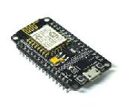NodeMCU is an open-source IoT stage. It consolidates firmware that abrupt spikes notable for the ESP8266 Wi-Fi SoC from Espressif Systems, and stuff which relies on the ESP-12 module. The articulation "NodeMCU" usually implies the firmware rather than the DevKit. The firmware uses the Lua scripting language. It relies on the eLua undertaking and subject to the Espressif Non-OS SDK for ESP8266. It uses many open source projects, for instance, lua - Jason, and spiffs.

**Fig 3.2. Node MCU**

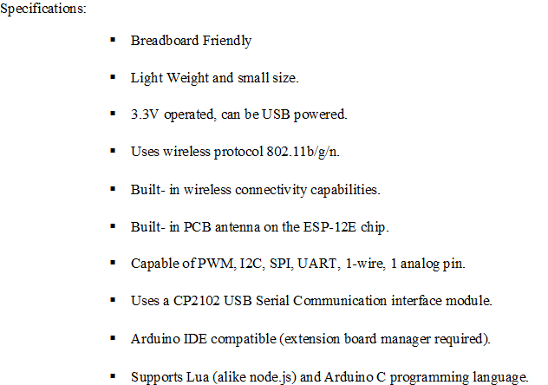

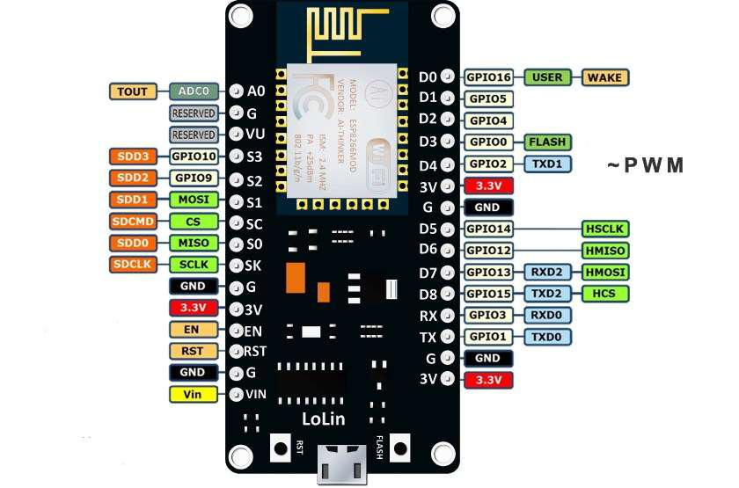

Fig 3.3. Node MCU Pin Configuration

**Chapter 4**

**IoT Technology and Applications**

**4.1 Introduction**

IoT improvement unexpectedly helps the IoT application that is centered on the heap commercial enterprise employer and precise clients, while networks and gadgets permit connectivity of bodily subjects. IoT software offers dependable vital device-to-human and device-to-tool communique. IoT tool programs need to ensure that records are received and properly acted consistent with a suitable precise way, a smooth example is that of logistic software program software monitoring that has the transported reputation of products which incorporates herbal merchandise, sparkling products, meat, and dairy terms. Moreover, inside the path of logistics, brilliant control of weather change, wonder and humidity are frequently monitored and appropriate moves are strategically and definitely made to keep gadgets spoilage from a long distance even as the connection is out of courage. To claimed that "a few examples of IoT programs in lifestyles can be placed in the clever environment, clever Greenhouse, clever cities, clever Water, smart Metering, safety and Emergency, commercial manipulate, domestic Automation and virtual health". '

IoT' is therefore stationed on devices that could look at sensed information and then transmit it to the individual. k. IoT annoying situations as said in a preceding look, there are some annoying conditions that IoT format needs to stand in the coming future generation. All of the devices, nodes related in associate in nursing IoT format desires to have substantially low latency over dependable hyperlinks. Because of the big style of IoT devices and the usage of several frequency bands, there can be a disaster in spectrum houses. Although IoT gadgets are growing daily that consumes exceptionally lesser strength, even though there can be a large quantity of greenhouse gasoline emission due to all of those devices. In the end, IoT structure now does not actually have to be price powerful but furthermore, they should be able to help heterogeneous applications and gadgets.

As said above in IoT stressful situations, IoT applications can have some extra smooth wants to tackle, for instance, device addressing, protection, Scalability, Mobility, Anchor-masses a great deal much less sending and so on. As noted, IoT packages include several heterogeneous gadgets, and but, content material safety is a key problem that plays a top-notch role.

A preceding study has indicated the annoying situations of each IoT and ICN in their past test, this beyond having a look at endeavors to combine them wherein IoT illustrate the great annoying situations and as an alternative, ICN illustrates the remarkable answers. Even though they observe defined to start with how one of a kind ICN competencies can cope with IoT problems and after that, some use times and contextual investigations are examined.

**4.2. Limitations**

The device has the following barriers:

1. Compatibility: As of now, there can be no preference for tagging and tracking with sensors. A uniform concept much like the USB or Bluetooth is needed which need to not be that hard to do.

2. Complexity: there are various opportunities for failure with complex systems. For instance, every you and your associate may also moreover acquire messages that the milk is over and every one of you can grow to be shopping for the equal. That leaves you with double the amount required. Or there may be a software program software worm causing the printer to order ink more than one time whilst it calls for a single cartridge.

3. privateers/protection: privateers is big trouble with IoT. All the statistics need to be encrypted genuinely so records approximately your financial repute or how a whole lot of milk you devour isn’t unusual information at the paintings place or together at the side of your pals.

Four. Safety: there is a threat that the software program can be hacked and your personal records misused. The possibilities are endless. Your prescription being changed or your account information being hacked might also additionally want to place you at the chance. Consequently, all the safety dangers grow to be the purchaser’s obligation.

**4.3. Ethernet:**

Ethernet is a circle of relatives of pc networking generation for nearby vicinity networks (LANs) commercially introduced in 1980. Standardized in IEEE 802.3, Ethernet has in large issue replaced competing burdened out LAN technologies.

Structures speaking over Ethernet divide a movement of information into man or woman packets known as frames. Everyone consists of delivering and tour spot addresses and mistakes-checking statistics certainly so damaged information may be detected and re-transmitted.

The requirements define numerous wiring and signaling variations. The actual 10BASE5 Ethernet used coaxial cable as a shared medium. Later the coaxial cables have been modified with the beneficial aid of twisted pair and fiber optic links collectively with hubs or switches. Facts costs had been periodically improved from the actual 10 megabits in step with 2d, to a hundred gigabits steady with 2nd.

**4.4. ETHERNET CABLE RJ45**

As you take into account that its commercial enterprise employer launch, Ethernet has retained an excellent diploma of compatibility. Competencies alongside aspect the forty eight-bit MAC deal with and Ethernet frame layout have stimulated considered one of a type networking protocols

Ethernet first of all competed within large element proprietary structures, Token Ring and Token Bus. due to the fact, Ethernet changed into able to adapt to marketplace realities and shift to a lot less expensive and ubiquitous twisted-pair wiring, those proprietary protocols soon decided themselves competing in a market inundated via Ethernet merchandise and via way of the give up of the Eighties, Ethernet become surely the dominant community era. Within the machine, 3Com has grown to be a primary agency that three hundred and sixty-five days commenced out promoting adapters for PDP-11s and VAXes, in addition to Multibus-based definitely Intel and solar Microsystems laptop structures. This has emerged as accompanied brief using DEC's Unibus to Ethernet adapter, which DEC provided and used internally to assemble its very non-public corporate network, which reached over 10,000 nodes through 1986, making it considered one of the most crucial laptop networks inside the worldwide at that element.

**4.5. Evolution:**

Ethernet developed to embody higher bandwidth, advanced media get right of entry to control strategies and unique bodily media. The coaxial cable turned into changed with element-to-thing hyperlinks related via Ethernet responders or switches to lessen installation costs, growth reliability, and beautify manipulation and troubleshooting. Many versions of Ethernet stay in normal use.

Ethernet stations speak using manner of way of manner of sending each certainly one of a type records packets: blocks of data for my part dispatched and brought. As with fantastic IEEE 802 LANs, each Ethernet station is given a 48-bit MAC deal. The MAC addresses are used to specify every holiday spot and the supply of every data packet. Ethernet connects link diploma connections, which can be told as the use of each holiday spot and delivery address. On receiving the data of a transmission, the receiver makes use of the vacation spot deal to decide whether or no longer the transmission applies to the station or needs to be ignored. Network interfaces typically do no longer take shipping of packets addressed to distinctive Ethernet stations.

Adapters which programmed with a globally unique cope with. An Ethertype vicinity in each person is utilized by the going for walks system on the side of receiving station to pick out the right protocol module (i.e. the net protocol module). Ethernet frames are stated to be self-identifying, due to the frame kind. Self-figuring out frames makes it feasible to intermix multiple protocols on an equal bodily network and forward a single pc to use more than one protocol together. However, the top-notch replaces in Ethernet, all generations of Ethernet (apart from early experimental variations) use the identical frame formats (and consequently the equal interface for better layers) and can be quite surely interconnected via bridging.

**4.6. ETHERNET (TCP/IP PROTOCOL)**

Ethernet is a circle of relatives of computer networking generation generally applied in nearby region networks (LAN), metropolitan vicinity networks (guy), and huge vicinity networks (WAN). [1] It has to turn out to be commercially added in 1980 and primary standardized in 1983 as IEEE 802.3,[2]and has given that been touchy to help higher bit expenses and longer hyperlink distances. Through the years, Ethernet has in large detail modified competing careworn LAN era which includes token ring, FDDI, and ARCNET.

The ideal 10BASE5 Ethernet makes use of coaxial cable as a shared medium, even as the extra modern Ethernet versions use twisted pair and fiber-optic links alongside hubs or switches. Over the path of its history, Ethernet statistics transfer expenses had been prolonged from the real 2. Ninety-four megabits in keeping with 2d (Mbit/s)[three] to the cutting-edge one hundred gigabits steady with 2nd (Gbit/s). The Ethernet requirements incorporate several wiring and signaling variations of the OSI physical layer in use with Ethernet.

Systems speaking over Ethernet divide a flow of data into shorter portions called frames. Anyone includes supply and excursion spot addresses, and errors-checking records so that broken frames may be detected and discarded; most usually, higher-layer protocols reason retransmission of out of area frames. As constant with the OSI version, Ethernet offers services as an awful lot as and which include the statistics link layer. [4]

Considering the truth that its business launch, Ethernet has retained a terrific degree of backward compatibility. Capabilities which encompass the forty-eight-bit MAC cope with and Ethernet body layout have inspired specific networking protocols. The number one possibility for a few uses of modern-day-day-day LANs IEEE 802.11.

**Data:**

Ethernet emerges as evolved at Xerox PARC inbetween 1973 and 1974.[6][7] It has become inspired via manner of the use of ALOHAnet, where Robert Metcalfe had studied as a part of his Ph.D. dissertation.[8] The concept become first documented in a note that Metcalfe wrote on May 22, 1973, in which he named it after the disproven aluminiferous ether as an "omnipresent, absolutely-passive medium for the propagation of electromagnetic waves".[6][nine][10] In 1975.

In 1976, after the gadget turns out to be deployed at PARC, Metcalfe and Boggs published a seminal paper

Metcalfe left Xerox from starting his career to June 1979 to shape 3Com.[6][14] He glades digital device enterprise (DEC), Intel, and Xerox to artwork collectively to sell Ethernet as an elegant. The so-known as "DIX" extensive, for "digital/Intel/Xerox", particular 10 Mbit/s Ethernet, with 48-bit excursion spot and delivery addresses and a global 16-bit Ether type-kind region. It grows to be published on September 30, 1980, as "The Ethernet, a nearby location network. Statistics hyperlink Layer and physical Layer specs".[15] version 2 modified into posted in November 1982[16] and defines what has to turn out to be known as Ethernet II. Formal standardization efforts proceeded on equal time and resulted inside the eBook of IEEE 802.three on June 23, 1983.[2]

Ethernet to begin with competed within big problem proprietary systems, Token Ring and Token Bus. because of the truth Ethernet grow to be able to adapt to marketplace realities and shift to less highly-priced and ubiquitous twisted-pair wiring, the ones proprietary protocols quickly decided themselves competing in a market inundated with the beneficial resource of Ethernet merchandise, and, by using the usage of the prevent of the Nineteen Eighties, Ethernet became sincerely the dominant network technology.[6] within the gadget, 3Com has ended up a primary corporation. 3Com shipped its first 10 Mbit/s Ethernet 3C100 NIC in March 1981, and that 12 months started out selling adapters for PDP-11s and VAXes, similarly to Multibus-primarily based sincerely Intel and solar Microsystems computer structures.[17]:9 This has become observed rapid through internally to build its private organization network, which reached over 10,000 nodes thru 1986, making it without a doubt one of the maximum important laptop networks within the worldwide at that component.[18] An Ethernet adapter card for the IBM laptop emerges as released in 1982, and, with the beneficial aid of 1985, 3Com had provided 100,000.[14] Parallel port primarily based absolutely completely Ethernet adapters have been produced for a time, with drivers for DOS and domestic windows. Through the early Nineties, Ethernet has to turn out to be so ordinary that it has grown to be a need-to-have function for contemporary pc systems, and Ethernet ports started to appear on a few laptop systems and most workstations. This method changed substantially speeded up with the introduction of 10BASE-T and its fairly small modular connector, at which difficulty Ethernet ports appeared even on low-save your motherboards.

thinking about then, Ethernet generation has advanced to meet new bandwidth and market requirements.[19] in addition to pc systems, Ethernet is now used to interconnect domestic tools and distinctive private gadgets.[6] it's miles used in commercial enterprise packages and is brief changing legacy statistics transmission structures in the worldwide's telecommunications networks.[20] thru 2010, the market for Ethernet devices amounted to over $16 billion in line with 12 months.

**4.7. STANDARDIZATION:**

In February 1980, IEEE began venture 802 to standardize community place networks (LAN).[14][22] The "DIX-organization" with Gary Robinson (DEC), Phil Artist (Intel), and Bob Prints (Xerox) submitted the so-known as "Bluebook" CSMA/CD specification as a candidate for the LAN specification.[15] Similar to CSMA/CD, Token Ring (supported via IBM) and Token Bus (decided on and henceforward supported thruway of good-sized motors) have been also considered as applicants for a LAN high-quality. Competing proposals and a large interest in the initiative introduced an approximately sturdy war of phrases over which era to standardize. In December 1980, the organization turned the break up into 3 groups, and standardization proceeded one after the opposite for every belief. [14]

Delays within the requirements device located at the chaos once the market advent of the Xerox film superstar computer and 3Com's Ethernet LAN merchandise. With such industrial company implications in thoughts, David Liddle (elegant supervisor, Xerox place of work systems) and Metcalfe (3Com) strongly supported an offer of Fritz Röscheisen (Siemens personal Networks) for an alliance within the developing workplace communique marketplace, which encompass Siemens' help for the global standardization of Ethernet (April 10, 1981). Ingrid Fromm, Siemens' consultant to IEEE 802, rapidly accomplished a broader beneficial resource for Ethernet beyond IEEE via the established order of a competing undertaking company "community Networks" inside the ECU necessities body ECMA TC24. In March 1982, ECMA TC24 with its enterprise human beings reached an agreement on a huge for CSMA/CD-based totally completely clearly at the IEEE 802 draft.[17]:8Because the DIX perception modified into most technically complete and due to the short movement took via ECMA which decisively contributed to the acknowledgement of opinions inside IEEE, the IEEE 802.3 CSMA/CD well-known have emerged as authorized in December 1982.[14] IEEE published the 802.3 modern-day days as a draft in 1983 and as a well-known in 1985.[23]

Approval of Ethernet on the global degree emerge as completed thru the usage of a comparable, pass-partisan motion with Fromm because the liaison officer strolling to combine with worldwide Electro technical fee (IEC) Technical Committee 83 (TC83) and worldwide business enterprise for Standardization (ISO) Technical Committee 90 seven Sub Committee 6 (TC97SC6). The ISO 8802-three elegant has grown to be posted in 1989.

**EVOLUTION**

Ethernet advanced to encompass better bandwidth, superior media get proper of entry to govern techniques and considered one in all a kind bodily media. The coaxial cable modified into changed with detail-to-detail hyperlinks associated thru Ethernet repeaters or switches.[25]

Ethernet stations communicate via the use of sending every unique facts packet: blocks of statistics in my opinion dispatched and added. The MAC address are used to specify each vacation spot and the delivery of each data packet. Ethernet establishes hyperlink diploma connections, which can be defined as the use of every holiday spot and supply address. On reception of a transmission, the receiver makes use of the vacation spot deal to decide whether or now or not or no longer the transmission applies to the station or needs to be omitted. A community interface generally does now not get keep of packets addressed to special Ethernet stations. [b]Adapters come programmed with a globally precise deal.

An EtherType place in anybody is used by the walking tool at the receiving station to select out the proper protocol module (e.g., an Internet Protocol model collectively with IPv4). Ethernet frames are said to be self-figuring out, because of the body type. Self-figuring out frames makes it feasible to intermix multiple protocols at the identical bodily network and allow an unmarried laptop to use a couple of protocols together.[26] however, in the evolution of the Ethernet era, all generations of Ethernet (apart from early experimental versions) use equal body codecs. [27] blended-tempo networks can be constructed with the usage of Ethernet switches and repeaters assisting the favored Ethernet versions

Because of the ubiquity of Ethernet, the ever-lowering fee of the hardware needed to the manual it, and the reduced panel vicinity wanted through twisted-pair Ethernet, most producers now construct Ethernet interfaces right away into laptop motherboards, eliminating the want for installation of a separate community card.

**Ethernet LAN capabilities:**

• Bus topology, burdened out LAN in IEEE 802.three bodily layer ultra-modern

• 10 Mbps, 100 Mbps (uncovered and Shielded wires), and four Gbps (in twisted-pair wiring mode)

• Broadcast medium─ Passive, compelled connections based genuinely.

• Body format just like the IEEE 802.2

• SNMP (smooth network control Protocol) Open the machine (therefore lets in a device of various specs)

• Everyone associated with a not unusual verbal exchange channel within the network will no longer be idle, waits and tries again.

• Multi get admission to is like in a Packet-switched network

**Ethernet Local Area Network**

• Passive, connection-based absolutely definitely

• Media get admission to control (MAC) forty-eight-bit deal with for transmitting and forwarding frames on same LAN simplest.

• can also use multicast addressing─for sending frames to all or a few pick out sorts of Ethernet gadgets

Connectivity to net

❖ Deal with desire Protocol (ARP) for solving 32 bits net protocol

Addresses with the forty-eight-bit excursion spot host media cope with. RARP (opposite ARP)

**Header Bytes in Ethernet frame**

➢ A statistics for transmission fragments into the frames.

➢ The body has a header.

➢ First of all, the header has 8 bytes, which defines a preamble.

➢ Then the header has six bytes (48-bits) of holiday spot MAC deals with.

➢ Six bytes (forty-eight-bits) of the deliver MAC deal with observe the destination MAC.

Information in Ethernet body:

• Then there are six bytes. The ones are for the type vicinity. Those are meaningful extremely good for the higher network layers and the period definition.

• Minimum seventy bytes and most 1500 bytes of facts comply with the duration definition.

• In the long run, there are four bytes for CRC check for the body series check

**GAS DETECTOR:**

A Gas detector also called a smoke alarm is a device that detects [smoke](http://en.wikipedia.org/wiki/Smoke), typically as an indicator of [fire](http://en.wikipedia.org/wiki/Fire). Commercial, industrial, and mass residential devices issue a signal to a [fire alarm system](http://en.wikipedia.org/wiki/Fire_alarm_system), while household detectors, known as smoke alarms, generally issue a local audible or visual [alarm](http://en.wikipedia.org/wiki/Alarm) from the detector itself.

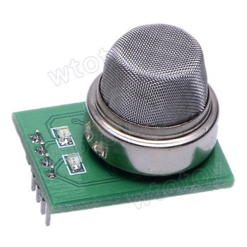

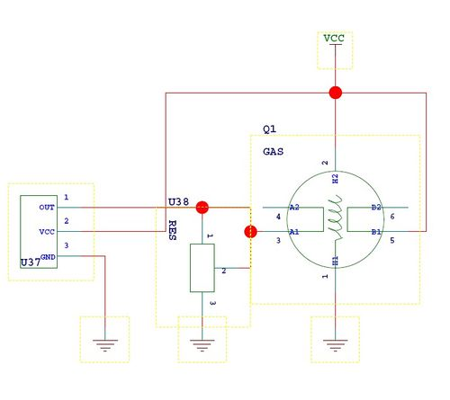

Gas detectors are typically housed in a disk-shaped plastic enclosure about 150 millimeters (6 in) in diameter and 25 millimeters (1 in) thick, but the shape can vary by manufacturer or product line. Most smoke detectors work either by optical detection ([photoelectric](http://en.wikipedia.org/wiki/Photodiode)) or by physical process ([ionization](http://en.wikipedia.org/wiki/Ionization)), while others use both detection methods to increase sensitivity to smoke. Sensitive alarms can be used to detect, and thus deter, smoking in areas where it is banned such as toilets and schools. Smoke detectors in large commercial, industrial, and residential buildings are usually powered by a central fire alarm system, which is powered by the building power with a battery backup. However, in many single family detached and smaller multiple family housings, a smoke alarm is often powered only by a single disposable battery.

In the United States, the National Fire Protection Association estimates that nearly two-thirds of deaths from home fires occur in properties without working smoke alarms/detectors.

**SOFTWARE DESCRIPTION**

**6.0. Arduino IDE compiler:**

Arduino is an open-deliver electronics platform based mostly on smooth-to-use hardware and software utility. Arduino boards can observe inputs - slight on a sensor, a finger on a button, or a Twitter message - and flip it into an output - activating a motor, turning on an LED, publishing a few components online. You could tell your board what to do by sending a hard and fast of commands to the microcontroller at the board. To do so that you use the Arduino programming language (based totally mostly on Wiring), and the Arduino software (IDE), based on Processing.

Over the years Arduino has been the brain of lots of obligations, from regular gadgets to complex medical gadgets. A worldwide community of makers - college students, hobbyists, artists, programmers, and specialists - has collected spherical this open-deliver platform, their contributions have brought as much as a terrific amount of available know-how that can be of terrific assist to novices and experts alike.

Arduino has become born on the Ivrea interaction format Institute as a clean tool for instant prototyping, geared towards university college students without a historic past in electronics and programming. As quickly as it reached a miles wider community, the Arduino board started converting to conform to new dreams and traumatic situations, differentiating its provide from smooth eight-bit boards to merchandise for IoT

Programs, wearable, three-d printing, and embedded environments. All Arduino boards are without a doubt open-deliver, empowering clients to assemble them independently and ultimately adapt them to their unique dreams. The software program, too, is open-supply, and its miles growing thru the contributions of customers globally.

The advantages of the Arduino IDE utility are

1. much less steeply-priced

2. The clean smooth programming surroundings

3. Extensible software program application utility and hardware



Arduino IDE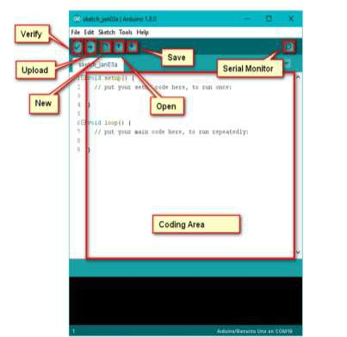

Fig Using Arduino IDE app

The Arduino venture gives the Arduino blanketed development surroundings (IDE), it really is a go-platform software program software developed in the programming language Java. It is developed to introduce programming application with software improvement.

It includes a code editor with features in conjunction with syntax highlighting, brace matching, and automatic indentation, and offers a simple one-click mechanism to collect and load packages to an Arduino board. A software program written with the IDE for Arduino is known as a "cool lively film".

Arduino IDE permits the languages C and C++ the use of special hints to set up code. The Arduino IDE materials a software program software library called Wiring from the Wiring task, which offers many, not unusual enter and output techniques. a massive Arduino C/C++ cool animated film embodies abilities that might be compiled and related with a utility stub vital() into an executable cyclic government software:

• Setup (): a feature that runs as fast as on the start of software and which can initialize settings.

• loop (): a characteristic called time and again until the board powers off.

• Writing Sketches

• Report

• Edit

• Caricature

• Equipment

• help

• Sketchbook

• Tabs, more than one documents, and Compilation

• importing

• Libraries

• Hardware

• Serial screen

• Possibilities

• Language assist

• Forums

The Arduino Software (IDE) - carries a text editor for writing code, a message location, a text console, a toolbar with buttons for all functions, and a group of menus. It joins to the Arduino and Genuino hardware to add packages and talk with them.

**6.1. WRITING SKETCHES:**

Packages written utilizing Arduino software application program (IDE) are called sketches. Those sketches are written inside the textual content editor and saved with the document extension .ino. The editor has capabilities for slicing/pasting and for searching/changing textual content. The message area gives comments while saving and exporting and presentation errors. The console shows text output thru the use of the Arduino software program (IDE), together with complete error messages and distinctive records. The lowest right-hand nook of the window suggests the configured board and serial port. The toolbar buttons permit you to verify and upload packages, create, open, and keep sketches, and open the serial show.

• verify

Assessments your code for compiling it.

• upload

Compiles your code and uploads it to the board. See importing below for facts.

• Notice: if you are using an of doors programmer together with your board, you may hold down the "shift" key for your pc while the usage of this icon. The textual content will trade to "add the use of Programmer"

• New

Creates an ultra-modern caricature.

• Open

In case you need to open a caricature overdue under the listing, use the document | Sketch book menu as an alternative.

• hold

Saves your cool animated film.

• Serial display

Opens the serial screen.

Additional instructions are decided inside the five menus: record, Edit, caricature, gear, and help.

File:

• New

Creates today's instance of the editor, with the naked minimum form of a sketch already in the area.

.

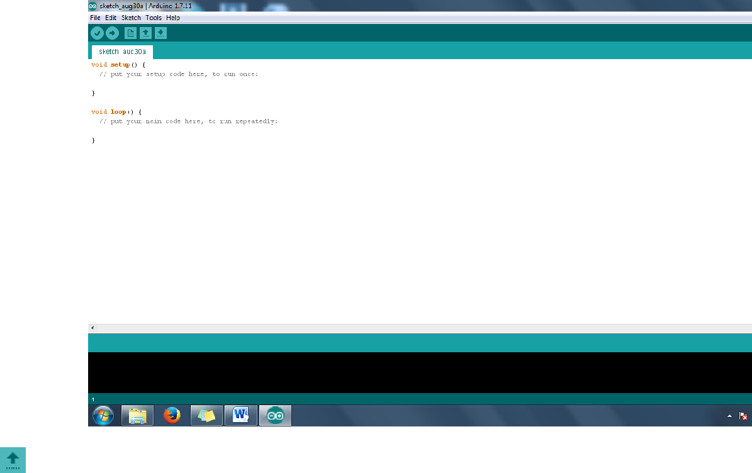

Figure no:6.1. Create a new sketch

• Open

Allows loading a caricature file surfing via the pc drives and folders.

• Open current-day

Provides a brief listing of the maximum ultra-modern sketches, equipped to be opened.

• Sketchbook

Suggests the contemporary-day sketches in the sketchbook folder shape; clicking on any call opens the corresponding cool animated film in a modern-day editor instance.

• Examples

Any instance supplied with the useful aid of the Arduino software program application (IDE) or library suggests up on this menu item. All of the examples are based on a tree that lets in clean get proper of entry to by way of the usage of subject matter or library.

• keep

Saves the caricature earlier then, a call might be supplied in a "shop as.” window.

• save as...

Let’s in to maintain the cutting-edge cool animated film with a wonderful name.

• Internet page Setup

It suggests the net page Setup window for printing.

• Print

Sends the cutting-edge cartoon to the printer in step with the settings defined in net web page Setup.

• Options

Opens the possibilities window wherein a few IDE settings may be customized, because of the fact that language of the IDE interface.

• give up

Closes all IDE windows. The identical sketches open whilst give up turned into chosen can be robotically reopened the subsequent time you begin the IDE.

• Edit

Write the program.

• Undo/Redo

is going decrease once more of 1 or extra steps you did at the equal time as editing; while you skip decrease returned, you can move in advance with Redo.

• duplicate

Duplicates the selected text inside the editor

• Reproduction for discussion board

• Reproduction as HTML

• Paste

Places the contents of the clipboard on the cursor feature, in the editor.

• select all

Selects and highlights the complete content material of the editor.

• Statement/Uncomment

Places or gets rid of the // observation marker at the start of every decision online.

• increase/lower Indent

Adds or subtracts an area at the beginning of each decided online, transferring the textual content one area at the proper or disposing of an area on the start.

• locate

Opens the discover and update window in which you could specify the text to search inside the cutting-edge-day comedian strip in keeping with numerous alternatives.

• locate next

Highlights the fact that is trying to find the item within the known window, relative to the cursor role.

• discover preceding

Highlights the seek item within the discover window relative to the cursor position.

Caricature:

• verify/acquire

Assessments your comic strip for errors compiling it; it's going to document reminiscence utilization for code and variables in the console vicinity

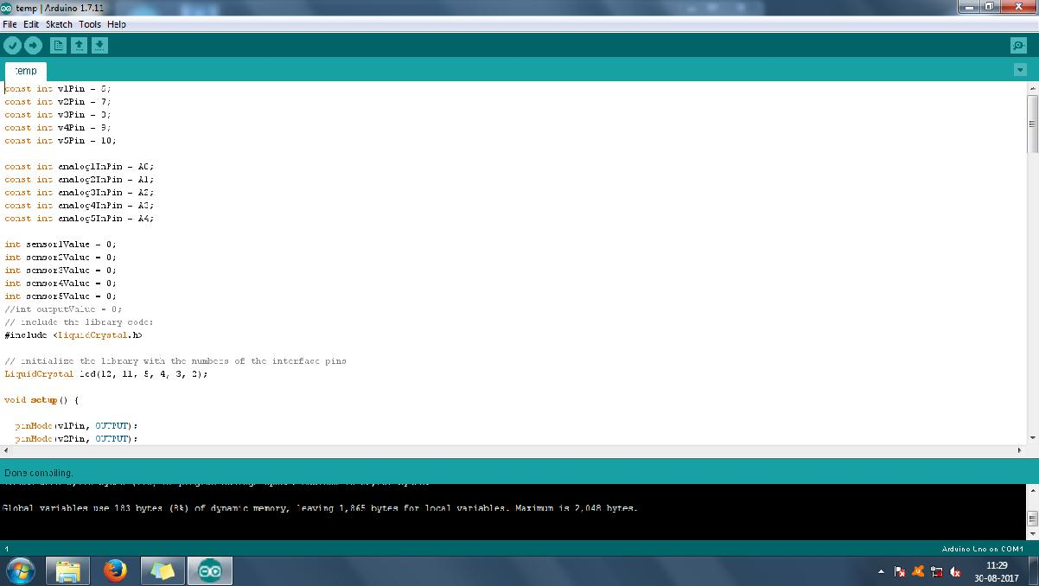

.

Fig 6.2. verify/compile

• upload

This may overwrite the bootloader at the board; you could want to use device > Burn Bootloader to restore it and be capable of add to the USB serial port another time. However, it permits you to apply the overall functionality. To acquire this a system -> Burn Bootloader command needs to be accomplished.

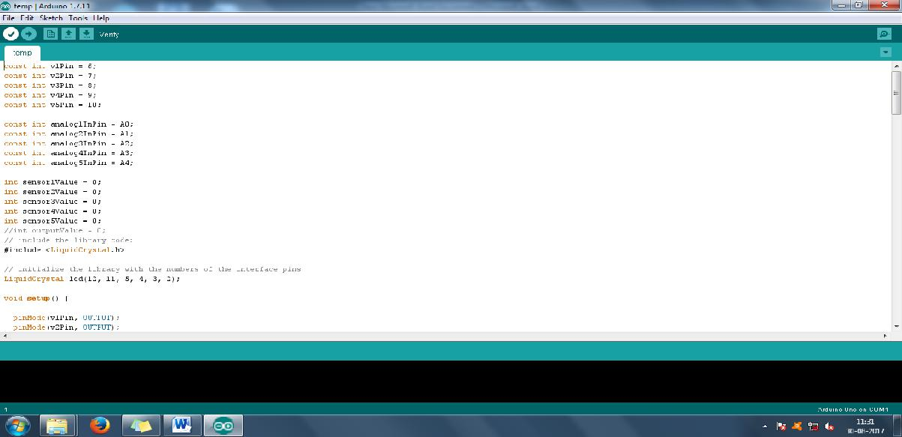

Fig 6.3.load the binary file

• Export Compiled Binary

Saves a .hex record that can be saved as an archive or sent to the board using various equipment.

• encompass Library

Gives a library on your caricature with the aid of placing #encompass statements at the beginning of your code. For more facts, see libraries under. Moreover, from this menu item, you could get proper access to the Library

• add report...

Adds a supply file to the comedian strip (it will be copied from its present-day area). the present-day day document seems in an ultra-present day tab in the cool animated film window. Documents may be eliminated from the strip the normal use of the tab menu available clicking on the lower triangle icon below.

**Device:**

• Automobile layout

This formats your code properly: i.e. indents it simply so beginning and remaining curly braces

• Archive comedian strip

Documents a replica of the current-day cool lively movie in .zip format. The archive is placed in the equal listing because of the comedian strip.

• Recovery Encoding & Reload

Fixes viable discrepancies in most of the editor char map encoding and exceptional on-foot structures char maps.

• Board

Pick out the board which you're the use of. See underneath for descriptions of the numerous boards.

• Port

This menu consists of all the serial devices (real or digital) for your device. It wants to routinely refresh each time you open the top-stage equipment menu.

• Programmer

For choosing a hardware programmer whilst programming a board or chip and not the usage of the onboard USB-serial connection. Normally you may not need this, however, if you're burning a bootloader to a new microcontroller, you could use this.

• Burn Bootloader

The gadgets on this menu will allow you to burn a bootloader on to the mcu on an Arduino board. This isn't always required for use of an Arduino uno or Genuino board but is beneficial if you purchase an extremely-cutting-edge ATmega microcontroller (which usually comes without a bootloader). Ensure which you've decided on the right board from the boards' menu in advance than burning the bootloader on the reason board. This command additionally sets the proper fuses.

Help:

Right here you find out easy access to several files that encompass the Arduino software program utility (IDE). You’ve got have been given get proper of entry to Getting started, Reference, this manual to the IDE and distinct files regionally, without an internet connection. The documents are a neighborhood reproduction of the internet ones and can hyperlink once more to our online net internet web page.

• DISCOVER IN REFERENCE

This is the pleasant interactive characteristic of the assist menu: it straight away selects the applicable net page in the close by a duplicate of the Reference for the characteristic or command beneath the cursor.

**LANGUAGE SUPPORT**

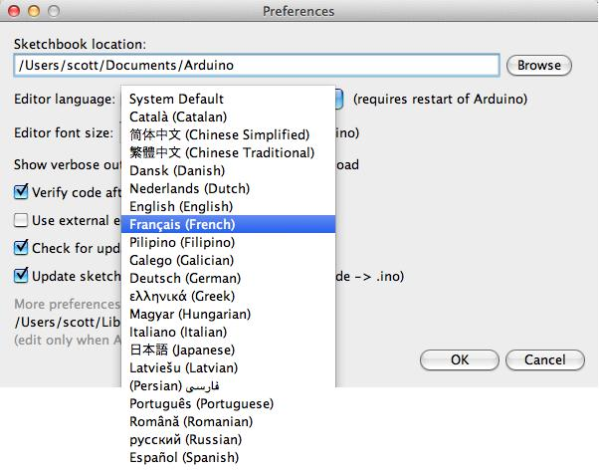

**SERIAL MONITOR:**

Indicates serial facts being despatched from the Arduino UNO or Genuino board (USB or serial board). To ship data to the board, enter textual content and click on on on at the "supply" button 36 2336 or press enter. Choose out the baud price from the drop-down that fits to Serial. 12 Begin in your comic strip. Be conscious that on domestic home windows, Mac or Linux, the Arduino UNO or Genuino board will reset whilst you join with the serial display.

You could also interface to the board from Processing, Flash, MaxMSP, and so on (see the 12 interfacing net page for information). Possibilities: A few picks can be set inside the options dialog (determined under the Arduino menu on the 36 Mac, or document on home windows and Linux). The relaxation can get in the options file, 12 whose region is confirmed in the choice conversation.

Arduino software (IDE) consists of the built-in to beefit for the forums in the following listing, all primarily based on the AVR mcu. The Boards manager included inner the fashionable set up allows to feature assist for the growing variety of new boards based totally on special cores like Arduino UNO, Arduino 0, Edison, Galileo and so on.

• Arduino Yùn

An ATmega32u4 frequency at 16 MHz with auto-reset, 12 Analog Input pins, 20 virtual I/O, and 7 PWM.

• Arduino/Genuino Uno

An ATmega328 frequency at 16 MHz with automobile-reset, 6 Analog Input, 14 virtual I/O, and 6 PWM.

An ATmega168 strolling at 16 MHz with car-reset.

• Arduino Nano w/ ATmega328

An ATmega328 has a frequency of 16 MHz with automobile-reset. Has eight analog inputs.

• Arduino/Genuino Mega 2560

An ATmega2560 has a frequency of at sixteen MHz with automobile-reset, 16 Analog In, 54 virtual I/O, and 15 PWM.

• Arduino Mega

An ATmega1280 has a frequency of 16 MHz with vehicle-reset, 16 Analog In, fifty 4 virtual I/O, and 15 PWM.

• Arduino Mega ADK

An ATmega2560 on foot at sixteen MHz with vehicle-reset, sixteen Analog In, fifty-four digital I/O, and 15 PWM.

• Arduino Leonardo

An ATmega32u4 running at 16 MHz with auto-reset, 12 Analog Input, 20 virtual I/O, and seven PWM.

• Arduino/Genuino Micro

An ATmega32u4 has a frequency of 16 MHz with car-reset, 12 Analog Input, 20 virtual I/O, and seven PWM.

• Arduino Esplora

ATmega32u4 jogging at sixteen MHz with car-reset.

• Arduino Mini w/ ATmega328

An ATmega328 has a frequency of 16 MHz with vehicle-reset, eight Analog In, 14 virtual I/O, and six PWM.

• Arduino Ethernet

Equal to Arduino UNO with an Ethernet defend An ATmega328 jogging at 16 MHz with car-reset, 6 Analog In, 14 digital I/O, and six PWM.

• Arduino Fio

ATmega328 jogging at eight MHz with automobile-reset. equal to Arduino seasoned or Pro Mini (3.3V, 8 MHz) w/ATmega328, 6 Analog In, 14 virtual I/O, and 6 PWM.

• Arduino BT w/ ATmega328

ATmega328 has a frequency of sixteen MHz. The bootloader burned (four KB) consists of codes to initialize the on-board Bluetooth module, 6 Analog In, 14 digital I/O, and 6 PWM.

• LilyPad Arduino USB

An ATmega32u4 frequency at 8 MHz with vehicle-reset, four Analog In, nine digital I/O, and four PWM.

• LilyPad Arduino

An ATmega168 or ATmega132 walking at 8 MHz with vehicle-reset, 6 Analog Input, 14 virtual I/O, and 6 PWM.

• Arduino seasoned or Pro Mini (5V, sixteen MHz) w/ ATmega328

An ATmega328 taking walks at sixteen MHz with vehicle-reset. Identical to Arduino Duemilanove or Nano w/ ATmega328; 6 Analog Input, 14 virtual I/O and six PWM.

• Arduino NG or older w/ ATmega168

An ATmega168 frequency at 16 MHz without car-reset. Compilation and add is identical to Arduino Diecimila ATmega168, however, the bootloader burned has a slower timeout (and blinks the pin thirteen LED three times on reset); 6 Analog Input, 14 virtual I/O, and six PWM.

• Arduino robotic manage

An ATmega328 frequency at 16 MHz with vehicle-reset.

• Arduino robotic Motor

An ATmega328 on foot at sixteen MHz with automobile-reset.

• Arduino Gemma

An ATtiny85 frequency at eight MHz with automobile-reset, 1 Analog In, three digital I/O, and more than one PWM.

**BLYNK APP**

**How Blynk Works?**

Blynk was designed for the Internet of Things. It can control hardware remotely, it can display sensor data, it can store data, visualize it and do many other cool things.

There are three major components in the platform:

1. **Blynk App** - allows to you create amazing interfaces for your projects using various widgets we provide.
2. **Blynk Server** - responsible for all the communications between the smartphone and hardware. You can use our Blynk Cloud or run your [private Blynkj server](https://docs.blynk.cc/#blynk-server) locally. It’s open-source, could easily handle thousands of devices and can even be launched on a Raspberry Pi.
3. **Blynk Libraries** - for all the popular hardware platforms - enable communication with the server and process all the incoming and out coming commands.

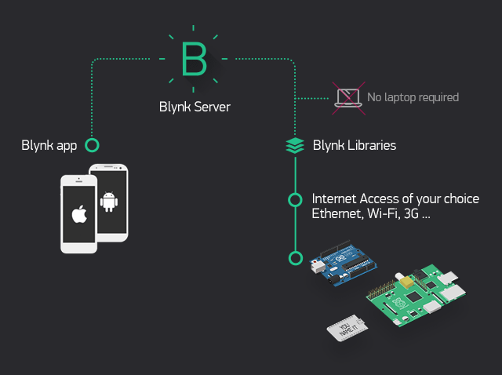

**Fig 4.1: Blynk interfacing**

**4.2 Arduino Ide Setup Process**

**Arduino IDE** is an open source software that is mainly **used** for writing and compiling the code into the **Arduino** Module. The main code, also known as a sketch, created on the **IDE** platform will ultimately generate a Hex File which is then transferred and uploaded in the controller on the board.

The node MCU needs some external libraries for accessing the commands for it. For instating node MCU library the fallowing link must be placed in the board manager which is present in options tools of the arduino IDE software.

The link is : <http://arduino.esp8266.com/stable/package_esp8266com_index.json>

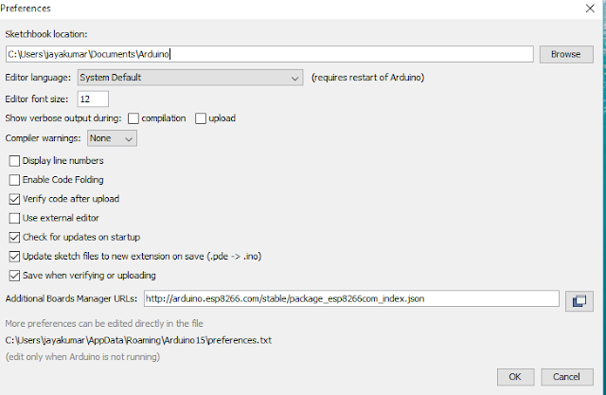

Fig 4.2 : Installation of nodeMCU board

**4.3 blynk library**

Download the latest **Blynk_Release_vXX.zip** file from the GitHub page:

**Blynk library should be installed manually. Follow the instructions:**

1. Unzip the **Blynk_Release_vXX.zip** archive. You will notice that archive contains several folders and several libraries.
2. Copy all of these libraries to **your sketchbook folder** of **Arduino IDE**.

To find the location of **your sketchbook folder**,go to top menu in Arduino IDE:**Windows:***File → Preferences*

The structure of your **your sketchbook folder**should now look like this, along with your other sketches (if you have them):

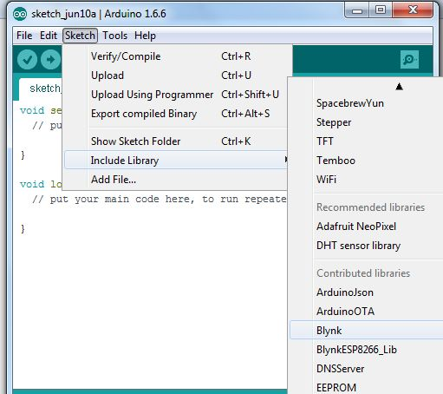

Fig 4.3 : Installing Blynk library

**5.1 PROCEDURE FOR CREATION AND CONNECTING BLYNK TO MICRO CONTROLLER**

1. **Create a Blynk Account**

After you download the Blynk App, you’ll need to create a New Blynk account. This account is separate from the accounts used for the Blynk Forums, in case you already have one.

We recommend using a real email address because it will simplify things later.

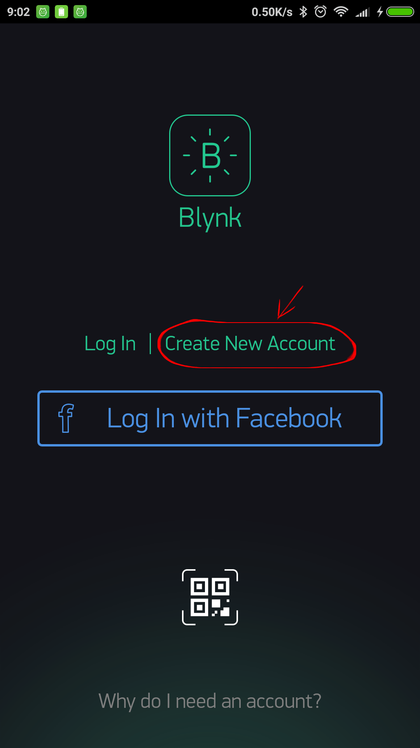

Fig 5.1 : Creation of blynk account

1. **Create a New Project**

After we have successfully logged into our account, start by creating a new project. 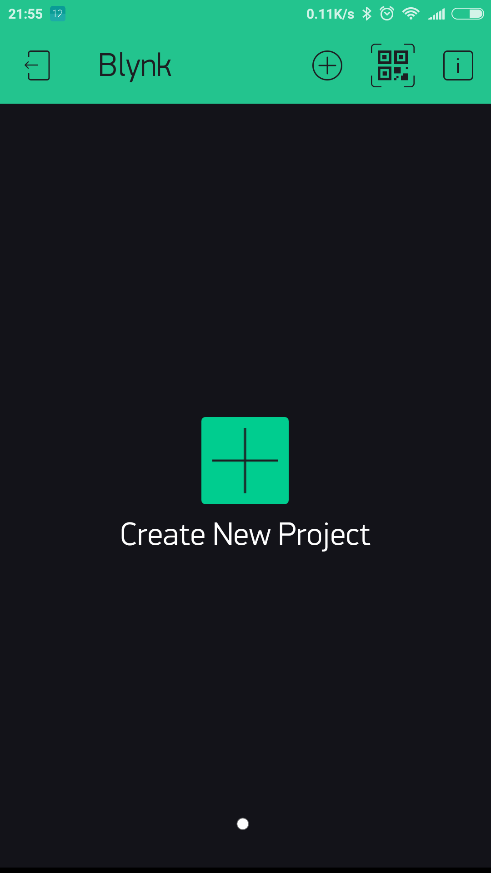

Fig 5.2 : Creation of a project

1. **Choose Hardware**

Select the hardware model that we will use.

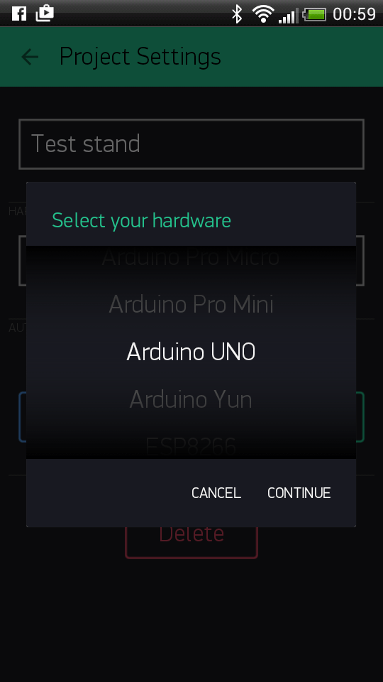

Fig 5.3 : Selection of controller

1. **Auth Token**

**Auth Token** is a unique identifier which is needed to connect our hardware to our smart phone. Every new project that we create will have its own Auth Token. We will get Auth Token automatically on your email after project creation. we can copy it manually. Click on devices section and selected required device : and we see the token.

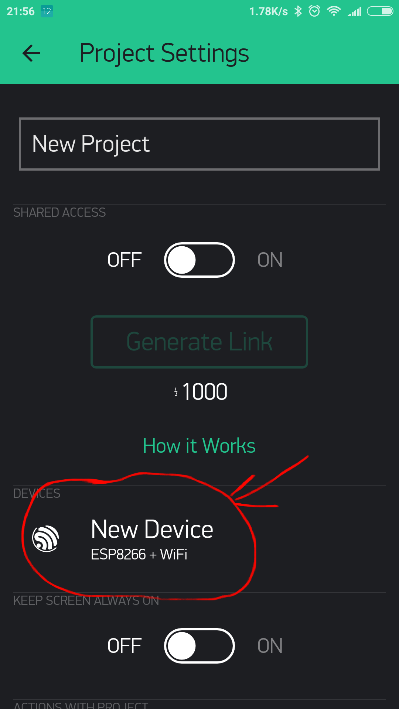

Fig 5.4 : Generation of auth token

1. **Blynk Tools Creation**

Required tools are taken and laced in proper positions. Various tools, Switches, joysticks, sliders, etc are available. The required video display, two joysticks, one button and GPS tools are taken.

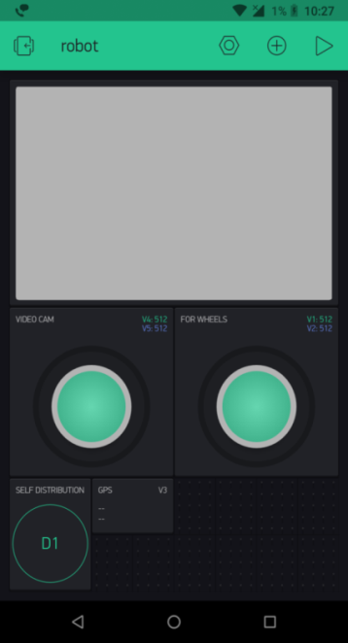

Fig 5.5 : App Appearance

1. **Internal Of Joystick**

Limits for the joystick are given and the refresh rate is also given so that the value is changed very frequently.

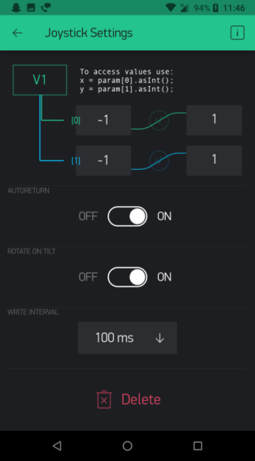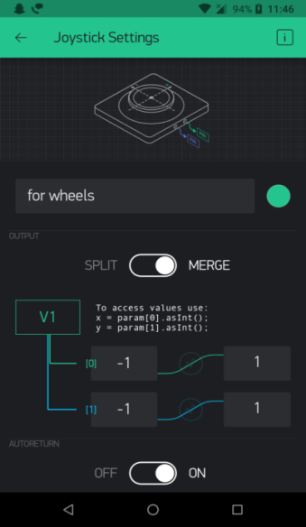

Fig 5.6 : Internal of Joystick

**Code:**

**/\*\*\*\*\*\*\*\*\*\*\*\*\*\*\*\*\*\*\*\*\*\*\*\*\*\*\*\*\*\*\*\*\*\*\*\*\*\*\*\*\*\*\*\*\*\*\*\*\*\*\*\*\*\*\*\*\*\*\*\*\***

**Download latest Blynk library here:**

**https://github.com/blynkkk/blynk-library/releases/latest**

**Blynk is a platform with iOS and Android apps to control**

**Arduino, Raspberry Pi and the likes over the Internet.**

**You can easily build graphic interfaces for all your**

**projects by simply dragging and dropping widgets.**

**Downloads, docs, tutorials: http://www.blynk.cc**

**Sketch generator: http://examples.blynk.cc**

**Blynk community: http://community.blynk.cc**

**Follow us: http://www.fb.com/blynkapp**

**http://twitter.com/blynk_app**

**Blynk library is licensed under MIT license**

**This example code is in public domain.**

**\*\*\*\*\*\*\*\*\*\*\*\*\*\*\*\*\*\*\*\*\*\*\*\*\*\*\*\*\*\*\*\*\*\*\*\*\*\*\*\*\*\*\*\*\*\*\*\*\*\*\*\*\*\*\*\*\*\*\*\*\***

**Youâ€™ll need:**

**- Blynk App (download from AppStore or Google Play)**

**- NodeMCU board**

**- Decide how to connect to Blynk**

**(USB, Ethernet, Wi-Fi, Bluetooth, ...)**

**There is a bunch of great example sketches included to show you how to get**

**started. Think of them as LEGO bricks and combine them as you wish.**

**For example, take the Ethernet Shield sketch and combine it with the**

**Servo example, or choose a USB sketch and add a code from SendData**

**example.**

**\*\*\*\*\*\*\*\*\*\*\*\*\*\*\*\*\*\*\*\*\*\*\*\*\*\*\*\*\*\*\*\*\*\*\*\*\*\*\*\*\*\*\*\*\*\*\*\*\*\*\*\*\*\*\*\*\*\*\*\*\*/**

**/* Comment this out to disable prints and save space */**

**#define BLYNK_PRINT Serial**

**#include <ESP8266WiFi.h>**

**#include <BlynkSimpleEsp8266.h>**

**//#include <SimpleTimer.h>**

**// You should get Auth Token in the Blynk App.**

**// Go to the Project Settings (nut icon).**

**//BlynkTimer timer;**

**#define PIN_UPTIME V5**

**char auth[] = "6rY3nw7kNItjl-HblUzTQTH09RNVubs8";**

**// Your WiFi credentials.**

**// Set password to "" for open networks.**

**char ssid[] = "SM";**

**char pass[] = "55555551";**

**float pollution;**

**int pollutionPin = 0; //analog pin 0**

**float sensorData;**

**int prevState = -1;**

**int currState = -1;**

**long lastChangeTime = 0;**

**BlynkTimer timer;**

**BLYNK_READ(PIN_UPTIME)**

**{**

**// // This command writes Arduino's uptime in seconds to Virtual Pin (5)**

**Blynk.virtualWrite(PIN_UPTIME, millis() / 1000);**

**sensorData = analogRead(A0); //reading the sensor on A0**

**Serial.println(sensorData);**

**//**

**Blynk.virtualWrite(V5, sensorData); //sending to Blynk**

**}**

**void myTimerEvent()**

**{**

**// You can send any value at any time.**

**// Please don't send more that 10 values per second.**

**Blynk.virtualWrite(V5, millis() / 1000);**

**sensorData = analogRead(0); //reading the sensor on A0**

**Serial.println(sensorData);**

**sensorData = (sensorData * 0.29765625); // costance (1/1024*100)**

**Blynk.virtualWrite(V5, sensorData); //sending to Blynk**

**}**

**void checkPin()**

**{**

**// Invert state, since button is "Active LOW"**

**int state = !digitalRead(2);**

**//Serial.println(state);**

**// Debounce mechanism**

**long t = millis();**

**if (state != prevState) {**

**lastChangeTime = t;**

**}**

**if (t - lastChangeTime > 50) {**

**if (state != currState) {**

**currState = state;**

**//Blynk.virtualWrite(V1, state);**

**}**

**}**

**prevState = state;**

**}**

**void setup()**

**{**

**// Debug console**

**Serial.begin(9600);**

**Blynk.begin(auth, ssid, pass);**

**// You can also specify server:**

**//Blynk.begin(auth, ssid, pass, "blynk-cloud.com", 8442);**

**//Blynk.begin(auth, ssid, pass, IPAddress(192,168,1,100), 8442);**

**// Setup a function to be called every second**

**//timer.setInterval(1000L, sendUptime);**

**// Make pin 2 default HIGH, and attach INT to our handler**

**// pinMode(4, INPUT_PULLUP);**

**timer.setInterval(1000L, myTimerEvent);**

**}**

**void loop()**

**{**

**Blynk.run();**

**checkPin();**

**timer.run(); // Initiates BlynkTimer**

**}**

**APPLICATIONS :** Data collection is the essential application of WSN and more importantly it is the foundation of other advanced applications in IOT environment

**ADVANTAGES :** Sensor data acquisition interface equipment is one of the key Parts in IOT applications.

**CHAPTER – VIII**

**CONCLUSION**

Now a day applications of Internet are increasing and IoT is the new era of the internet where daily life all things connected to internet and can be monitor & can be operate remotely from anywhere. This Project provides objectives of IoT, most of the application domains where IoT is used and the system architecture of IoT. Literature Survey provides the different Iot based existing system and gives details about the system. The proposed system of monitoring the pollution will reduce the air pollution.

**CHAPTER – IX**

**REFERENCES**

[1] Qingping Chi, Hairong Yan, Chuan Zhang, Zhibo Pang, and Li Da Xu, “A Reconfigurable Smart Sensor Interface for Industrial WSN in IoT Environment”, IEEE Transactions on IndustrialInformatics, Vol. 10, NO. 2, MAY 2014, pp. 1417-1425.

[2] Shifeng Fang, LidaXu ; Huan Pei ; Yongqiang Liu ; Zhihui Liu ; Yunqiang Zhu ; Jianwu Yan ; and Huifang Zhang, “An Integrated Approach to Snowmelt Flood Forecasting in Water Resource Management”, Industrial Informatics, IEEE Transactions, Volume:10 ,Issue: 1, April 2013, pp. 548 – 558.

[3] Cheong, P., Ka-Fai Chang, Ying-Hoi Lai, Sut-Kam Ho, Iam-KeongSou, and Kam-Weng Tam, “A ZigBeeBased Wireless Sensor Network Node for Ultraviolet Detection of Flame”, Industrial Electronics, IEEE Transactions, Volume 58 , Issue: 11, February 2011, pp. 5271 – 5277.

[4] Dr. V. Bhuvaneswari, Dr. R Porkodi, “The Internet of Things (IoT) Applications and Communication Enabling Technology Standards: An Overview”, International Conference on Intelligent Computing Applications, 2014, pp. 324-329

[5] R. KarpagaPriya, T. KarpooraEswari, and K. Akilakumari, “Industrial WSN in IOT Environment Interface with Smart Sensor Using ARM”, International Journal of Advance Research in Science And Engineering (IJARSE), Vol. No.4, Special Issue (02), February 2015, pp. 204-215.

[6] Bharani M., Elango S., Ramesh S.M., and Preetilatha R., “An Embedded System Based Monitoring System For Industries By interfacing Sensors With ATmega Microcontroller” International Journal of Advanced Research in Electronics and Communication Engineering (IJARECE) Volume 3, Issue 11, November 2014, pp. 1472-1474.

[7] GauravTiwari, RiyazKazi,”Realization of the Functions of Autonomic Smart Sensor Interface for Industrial in IOT Environment”, International Journal of Advanced Research in Computer Science and Software Engineering, (IJARCSSE) Volume 5, Issue 1, January 2015, pp. 878-883.

[8] S. Pandikumar and R.S. Vetrivel,“ Internet of Things Based Architecture of Web and Smart Home Interface Using GSM”, International Journal of Innovative Research in Science, Engineering and Technology(IJIRSET), Volume 3, Special Issue 3 , March 2014, pp. 1721-1727**.**